**Lab wireless - Guideline**

**Topics**

A. Wireless topologies

B. 802.11 protocol

**A. Wireless topologies**

WWAN:

- GSM, GPRS, CDMA, TDMA, EDGE, MBWA,

WMAN:

- 802.16 WiMAX

WPAN:

- Bluetooth, ZigBee

**B. 802.11 protocol**

- 802.11 physical layer

* RF (FHSS, DSSS), IR

- RF:

* 5GHz Unlicensed National Information Infrastructure (U-NII),
* 2.4GHz Industrial, Scientific, and Medical (ISM)

- 802.11 a,b,g,n,ac

***Ad-hoc Mode***

- Independent Basic Service Set (IBSS)

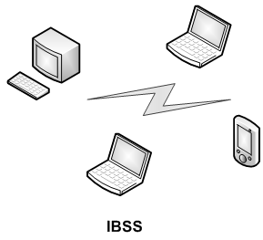

***Infrastructure Mode***

**-** Access Point (AP) – layer 2 device; role: bridge traffic

- AP and clients: BSS (Basic Service Set)

- Several BSS connected: ESS (Extended Service Set)

- SSID (Service Set Identifier:)

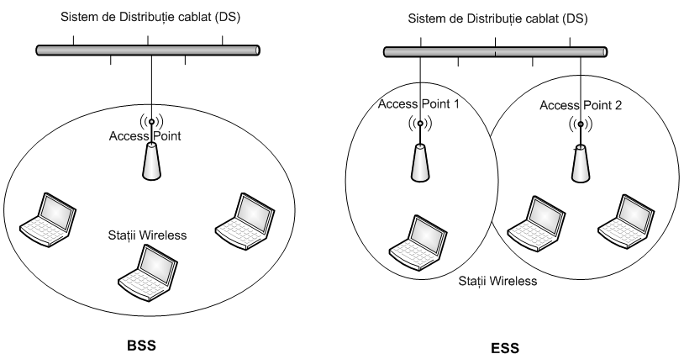

Example of wired/wireless topology using Wireless Routers and APs:

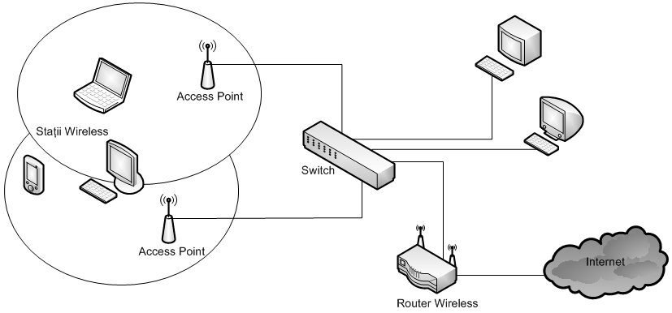

POE (Power over Ethernet)

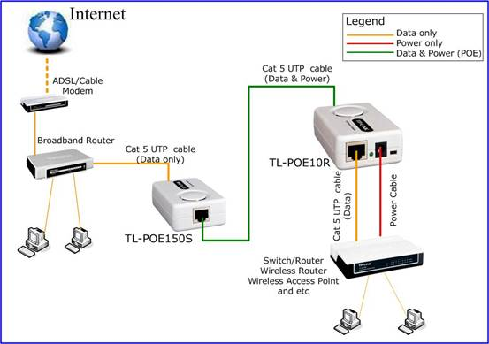

www.tp-link.us

Wifi Extender

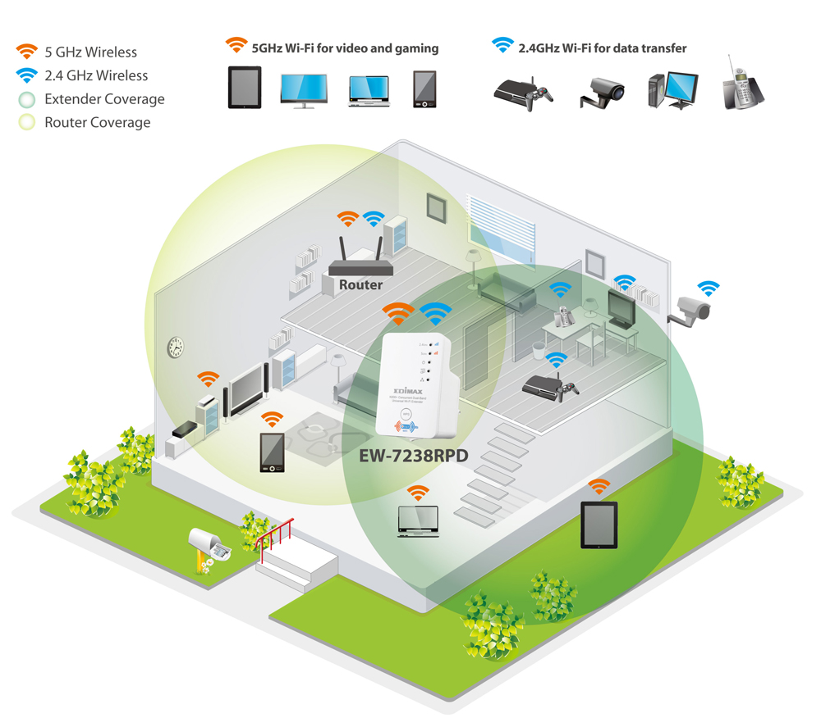www.edimax.com

Power line adapters (Powerline AV2/ HomePlug AV2 standard)

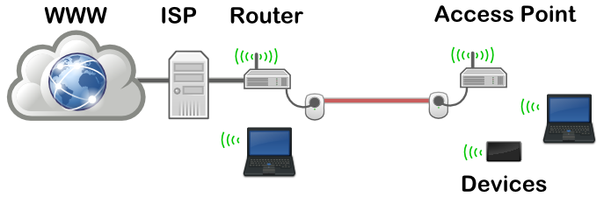

<http://tekeye.biz/>

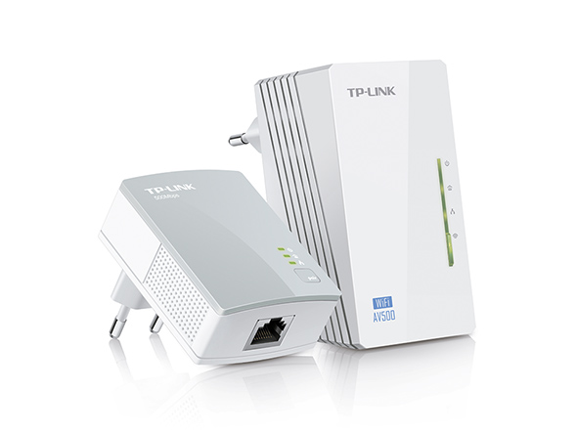www.tp-link.pt

Using VLANs on a network – different VLAN for WiFi

**Laboratory test configuration:**

|  |  |  |  |  |
| --- | --- | --- | --- | --- |
| **Device** | | **IP Address** | **Subnet mask** | **Default Gateway** |
| **Router** | Internet | DHCP | DHCP | DHCP |
| Wireless | 192.168.0.1 | 255.255.255.0 | - |
| **PCs, Laptop** | | 192.168.0.x Dynamic (DHCP) | 255.255.255.0 Dynamic (DHCP) | 192.168.0.1 Dynamic (DHCP) |

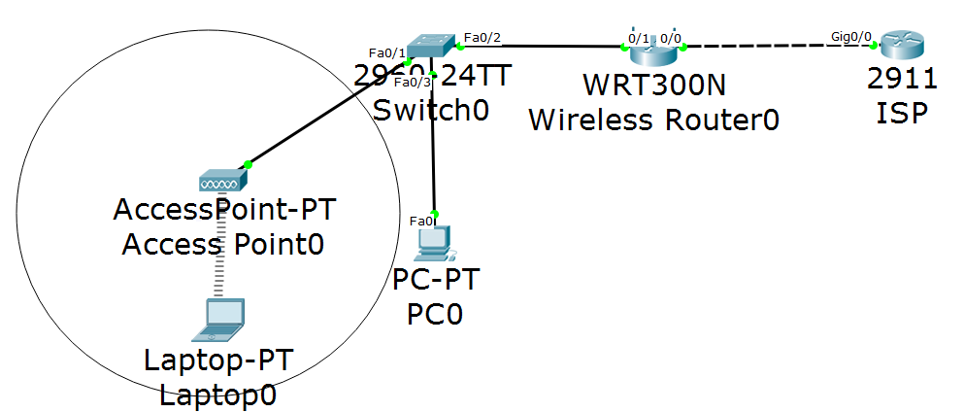

|  |  |  |  |  |  |
| --- | --- | --- | --- | --- | --- |
| **Device** | **SSID** | **Standard**  **Channel** | **Wireless**  **Sec. Protocol** | **Wireless**  **Password** | **Remote**  **Management**  **Password** |
| **Router Wireless** | Wi-Fi | 11 | WPA2 Personal | Cisco1234 | Pass1234 |

Copy the following configuration to router ISP, in the configuration mode:

hostname ISP

!

interface GigabitEthernet0/0

ip address 1.1.1.1 255.0.0.0

no shutdown

!

ip dhcp excluded-address 1.1.1.1

!

ip dhcp pool WiFi

network 1.0.0.0 255.0.0.0

default-router 1.1.1.1

dns-server 8.8.8.8

Test the connectivity.

1. ping <target IP> and tracert <target IP>

**Configure a wireless router:**

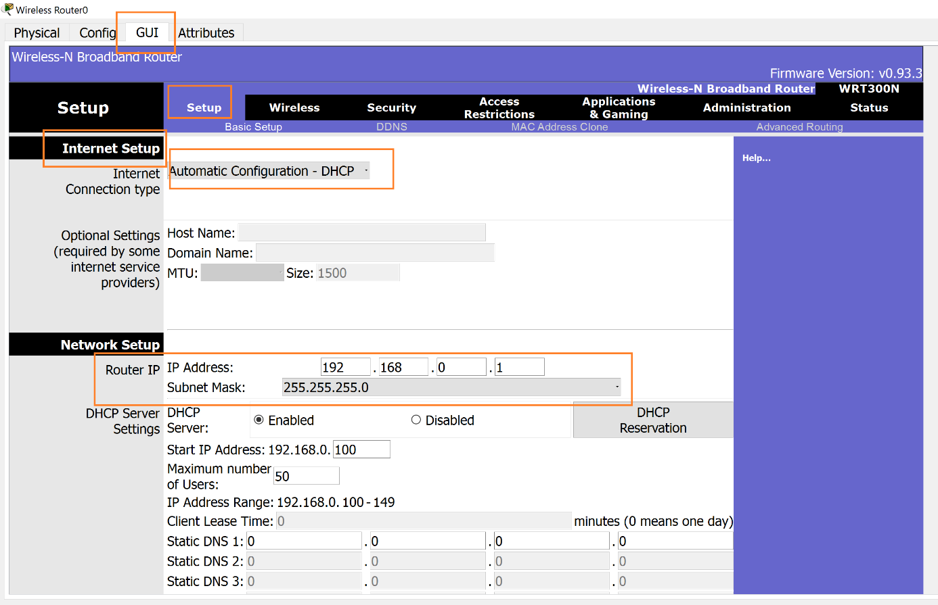

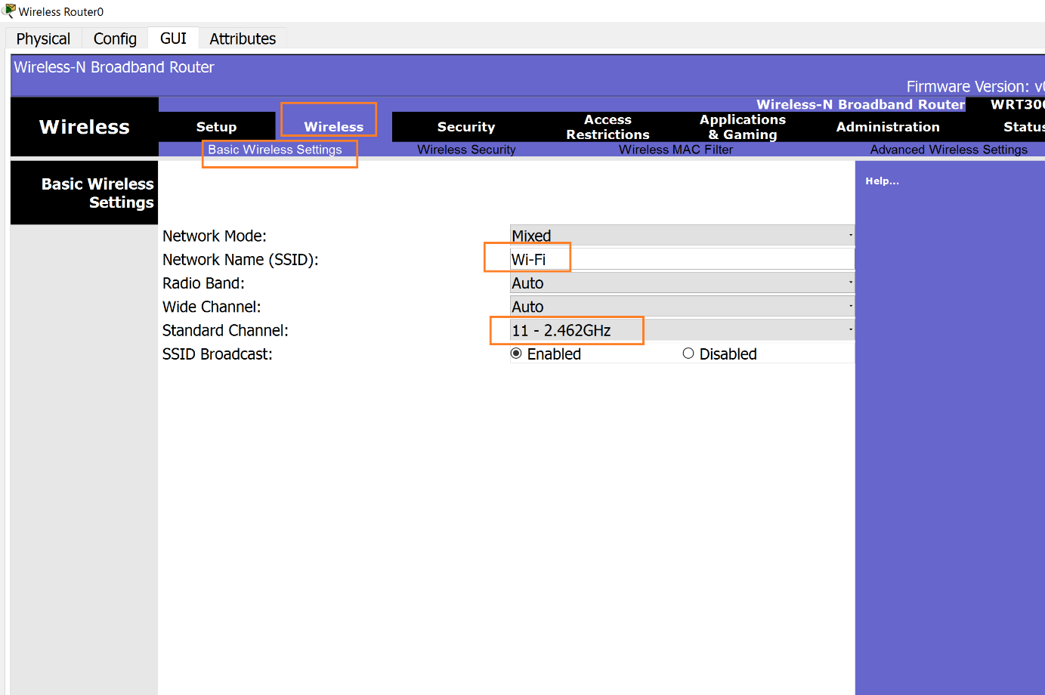

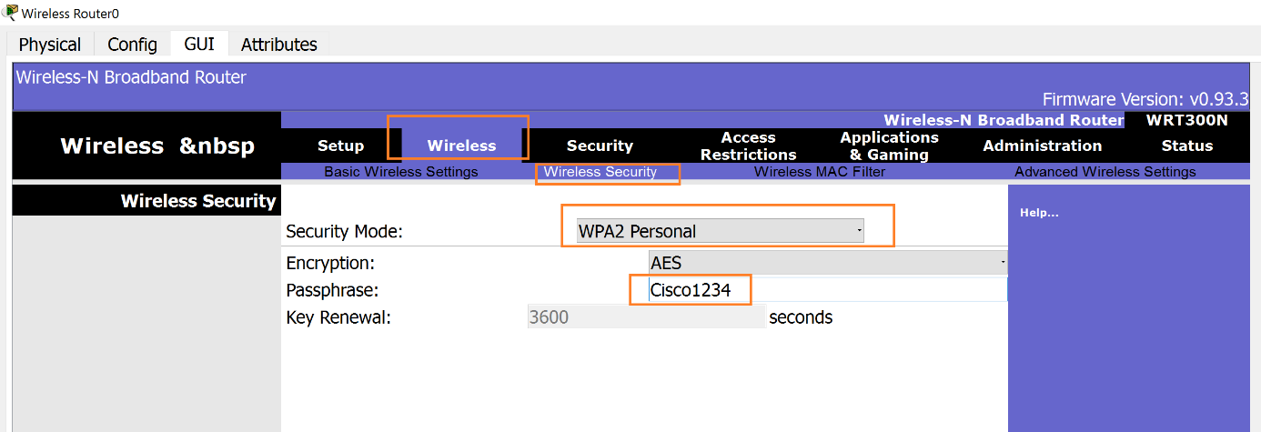

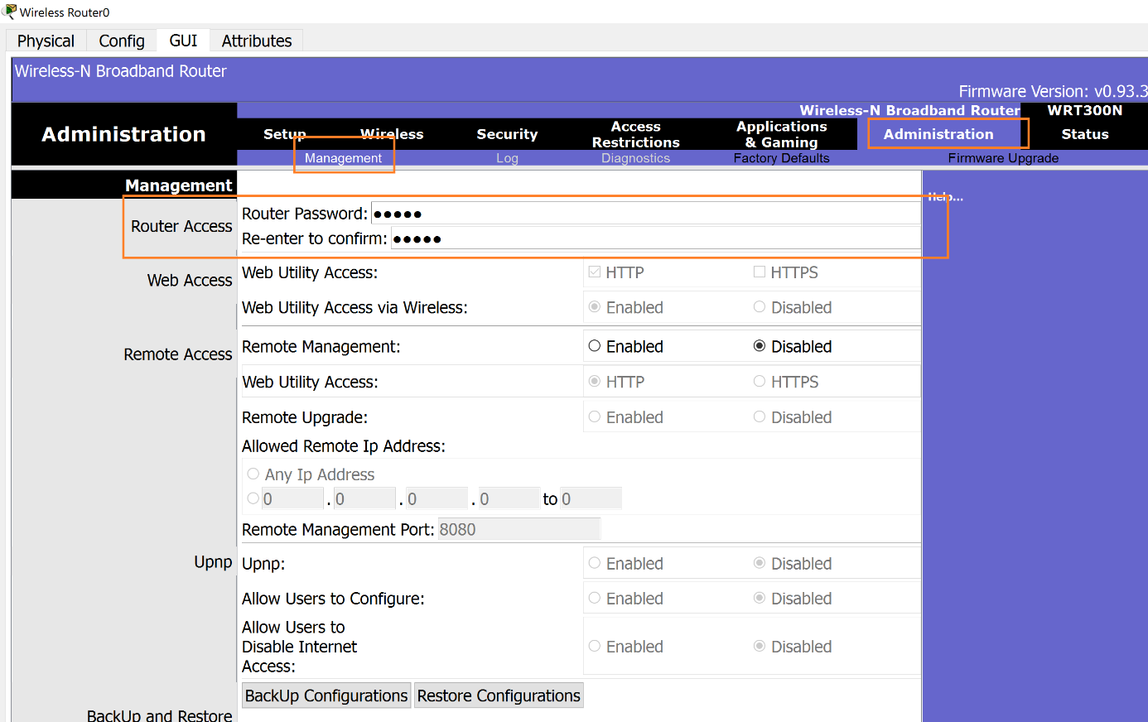

**Connect to a wireless AP from Laptop0:**

